CAQH (Council for Affordable Quality Healthcare) Instructions

Website: [CAQH ProView - Sign In](https://proview.caqh.org/Login?Type=PR)

You may also contact CAQH’s Solution Center for support with your profile:

* Access “Live Chat” on the CAQH website page.
  + Live Chat hours: Monday – Friday: 8:30 AM to 6:30PM (EST)
* Phone: 1-888-599-1771
  + Phone hours: Monday – Friday: 8 AM – 8 PM (EST)

If you are a returning user, please enter your username and password in the ‘Sign In’ section.

If you are new to CAQH, you may register by clicking this ‘register here’ link on the main log-in page:

From here you will follow the prompts and complete all the necessary fields. After doing so, you will receive an email with your CAQH ID #. This number will be important throughout your credentialing process. Please make sure to make note of this!

Fields for registration:

*NUCC Grouping: “Behavioral Health and Social Service Providers”

*Provider Type: Please select the option that best represents your hired role.

*Please complete all fields that are marked by a red asterisk (*) within CAQH. We also encourage you to fill out any non-required fields you can. Below we specify the minimum required fields.

**Sections with red bars at the side are not necessarily required fields. If the box is shaded pink, that IS a required field (**SEE BELOW**).

***When Adding dates, it is often easier to type them in. But you must manually type the dash (/) between numbers.

When you successfully complete all necessary fields, you will see green checkmarks next to each section. (See below)

**\*\*If you are seeing a red X and you are confident that all information is complete and accurate. Please try clicking “Save & Continue”. The X sometimes does not update until you do so. If you are still having issues, please contact the above support line.**

Profile Data

**Personal Information:**

* Profile Setup
  + Please include any additional practice state(s).
* Names
  + Please include any name variations as stated.
* Address
  + Please include your personal “home” address here.
    - Select “Home” if given the option between Home and Work.
* Contact Info
  + Please include your personal contact information here.
* Personal Identification Numbers
  + This section asks for your NPI # - Information on how to apply for your NPI number is posted above the text box on CAQH. If you have any questions, please contact your credentialing coordinator or review the attached NPI/NPPES documentation in your welcome email.
* Demographics
  + Please include your birth city, state and country.
* Languages
  + Please include any non-English languages spoken.

**Professional IDs (as applicable):**

Please add all applicable professional IDs, even if not required with a red asterisk.

* Professional License
  + If you are a licensed clinician, please add each license you possess and fill out all required and unrequired information.
  + If you are an **UNLICENSED** clinician, please enter the following information as your “license”. CAQH requires this field. For the expiration date, please enter 3 years from the current date.
    - State: CO
    - License Number: 123
    - Currently Practicing: Yes

Enter the information that is outlined in Red on this page.

* License State: CO
* License Number: 123
* Expiration Date: 3 years from today’s date.
* DEA Registration
* CDS
* Medicare
* Medicaid
* ECFMG (Educational Commission for Foreign Medical Graduates)
* USMLE (United States Medical Licensing Examination)
* Prescriptive Authority (APN, NP, CNM, CNS, CRNA only)

**Education & Professional Training:**

* Beyond required boxes, please add:
  + Country
  + School
  + Address
  + Phone, Fax, Email
  + Degree
  + Course of Study/Major
  + Certificates
  + Graduation Date
* Please add any internship, residency, fellowship, preceptorship, procedural certificate course, etc. records under “Professional Training”

**Specialties:**

* Primary Specialty
* Secondary Specialty
* Additional Specialty
* Failed Board Examination
* Certifications (Please fill in supplemental information for certifications (certificate number, date of certification, expiry, etc.)
  + Qualified Autism Service Provider (QASP)
  + Cardiopulmonary Resuscitation (CPR)
  + Basic Life Support (BLS)
  + Advanced Cardiac Life Support (ACLS)
  + Advanced Life Support in OB (ALSO)
  + Health Care Provider (CoreC)
  + Advanced Trauma Life Support (ATLS)
  + Neonatal Advanced Life Support (NALS)
  + Neonatal Resuscitation Program (NRP)
  + Pediatric Advanced Life Support (PALS)
  + Other
* Clinical Practice
* Other Interests
* Other Professional Activities
* Special Experience, Skills, and Training
  + Please select all applicable answers from the list provided.

**Practice Locations:**

* There are 3 sections under Practice Locations:
  + Practice Details
  + Provider at the Location
  + Services and Resources

**You may see various warnings as seen in the pictures below:

Yellow Exclamation Point:

Red Exclamation Point:

**Practice Details**:

* Under practice details, we are having all providers enter our Independence location as that is the location of our tax ID. Please add Independence as your **PRIMARY** location. If you have other locations already added, you do not need to delete them.

Enter the information that is outlined in Red on this page.

* Practice Location: Jefferson Center for Mental Health
* Street 1: 4851 Independence Street
* City: Wheat Ridge
* State: CO
* Zip Code: 80033
* Country: United States
* County: Jefferson County
* Practice Location Website: <https://www.jcmh.org/>
* Phone Number: 303-425-0300
* Legal Business Name: Jefferson Center for Mental Health
* Tax ID: 84-0474717
* NPI: 1154403798

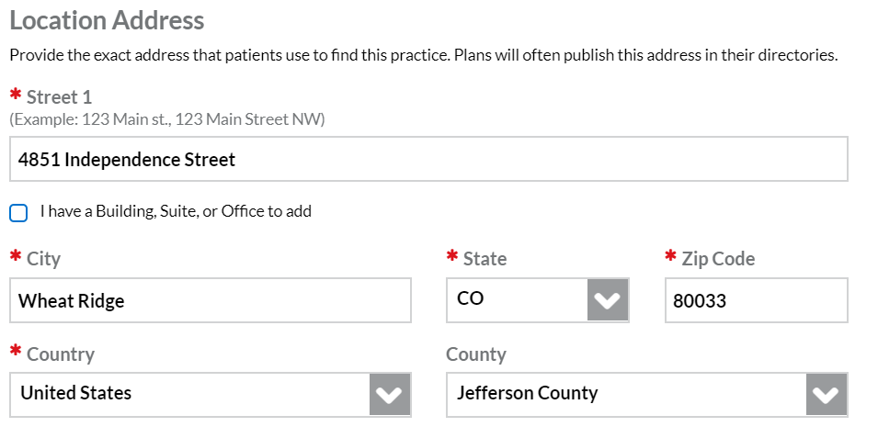

*If CAQH tells you that this information is incomplete and requires response, you may click the “eyeball” to edit the information in this section.

**Provider at the Location:**

You access this and the next tabs at the middle of your screen as seen below:



**Service and Resources:**

* The only required information in this section is adding an Office Manager:

Enter the information that is outlined in Red on this page.

* What support: Office Manager/Business Staff Contact
* First Name: Karen
* Last Name: Hess
* Email Address: karenhe@jcmh.org

**Hospital Affiliations:**

Please add any hospital affiliations as appropriate.

**Credentialing Contacts:**

Enter the information that is outlined in Red on this page.

* First Name: Karen
* Last Name: Hess
* Street: 4851 Independence Street
* City: Wheat Ridge
* State: CO
* Zip Code: 80033
* Country: United States
* Phone Number: 303-432-5115
* Fax Number: 303-432-5018
* Email Address: [karenhe@jcmh.org](mailto:karenhe@jcmh.org)
* Location: Select “Jefferson Center for Mental Health” from the dropdown that appears when you click in this field.

**Professional Liability Insurance:**

1. You **must** add Jefferson Center’s Liability Insurance information as seen below.
2. You may also add any personal professional liability if you hold your own policy and feel compelled to.
   1. This is **not** required for JCMH but can be helpful for personal tracking purposes.

Your screen should look like this. Click the blue ADD button.

Enter the information that is outlined in Red on this page.

* Policy Number: COP0002155
* Effective Date: 01/15/2024
* Expiration Date: 01/15/2025
* Select Jefferson Center from the “Covered Practice Location” dropdown
* Under Carrier, please click “Other (Not Listed)”
* Carrier Name: Conexus Insurance Partners
* Address: 3030 W. 81st Ave, Westminster, CO, 80031
* Coverage per Occurrence: $1,000,000
* Aggregated Amount: $3,000,000
* Individual Coverage: No
* Institution Affiliation: Jefferson Center for Mental Health

If requested:

* Unlimited Coverage: No
* Self-Insured: No

*Click Save & Continue

After the system saves your information, it will display a reminder that you need to upload your current insurance information and take you back to the original Professional Liability Insurance page. Please make sure that the FTCA Coverage box is **NOT CHECKED**. It should look like this:

**Employment Information:**

CAQH requires employment information from the past 10 years. **Please see our Credentialing Overview document for further guidance on employment information (e.g. gaps in employment)**

Enter the information that is outlined in Red on this page.

* Practice Location: Jefferson Center for Mental Health
* Street 1: 4851 Independence Street
* Country: United States
* Email Address: humanresources@jcmh.org
* City: Wheat Ridge
* State: CO
* Zip Code: 80033
* Phone Number: 303-425-5040
* Fax Number: 303-432-5018
* Start Date: List your start date
* Is this your current employer? Yes

**Professional References:**

Please include 3 professional references.

**Disclosure:**

All answers in this section are required. Please answer truthfully.

Please pay special attention to the Disclosure section on CAQH, specifically questions F and G under “Other Attestation Questions”.  Question F must be answered “yes” if you have any felony and/or misdemeanors, currently, or anytime in your past.  Question G must be answered “yes” if you have any of the specific felonies and/or misdemeanors (as outlined in Question G) currently, or anytime in your past.

**Global Authorization:**

* After you complete your disclosure information and “Save & Continue”, it will automatically take you to the authorization tab.

**You **MUST** turn on global authorization**

1. Click the “Authorize” tab at the top of the page
2. Select “Yes, release my data to any organization that requests access”
3. Click the box authorizing the release of your full self-reported information,
4. Click “SAVE”

**If returning to this tab after navigating away from it, CAQH may default to the “Organizations” submenu. If so, either click “Authorization Setting” or scroll down and click “Change Settings”



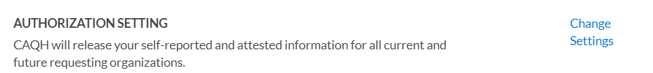

**Attestation:**

Once you have completed all your Profile Data, you should be directed to a page to “Review and Attest”. You **MUST** attest your attest your account.

If there are any errors within your application, it will not let you attest until they have been resolved. Please click the View Errors button to view and go back and correct them. When finish click the Review & Attest button.

After attestation, you are ready to upload your documents.

**SEE BELOW**

**Uploading Required Documents:**

**Uploading the Certificate of Liability Form**

*Please verify that the following fields on the Certificate of Liability Coverage Letter are filled out and match what was put in your Profile data:

* Date: (top left dropdown)
* Provider Name: (Including middle name or initials if they were noted in your profile data)
* NPI #
* CAQH #

**Steps**:

1. Login to your CAQH Profile
2. Click the Documents tab at the top of the page



1. Locate ‘Professional Liability Insurance’ and click the Upload button.
2. Browse your computer and select the previously saved cover letter with insurance information.
3. Click Upload.

Your screen should look like this. Click the Upload button.



Other Documents: **SEE BELOW**

**State Authorization and State Release**

As noted in the above picture, the State Authorization, State Release, and Standard Authorization, Attestation, and Release are required documents. Please complete and upload the versions included in your credentialing email rather than downloading from the CAQH website.

**Other Required Supporting Documents**

You will follow the same steps to upload all documents found on Required Supporting Documents included in your credentialing email.

**Document Statuses**

CAQH cross references submitted documents against your profile data. Documents will be in various statuses throughout this process. These include:

* Received: Document successfully uploaded and is being reviewed by CAQH.
* Rejected: There will be a prompt to “replace” the document. Please correct any errors and re-upload.
* Approved: The submitted document matched your profile data and was approved by the CAQH team
* Expired: The document is out of date. In most cases, you will have been required to upload a more up-to-date version of the required document and no further action is needed.

**This process can take 24-72 hours in most cases. You will **NOT** be emailed when these statuses change. Please check your profile regularly to verify that all submitted documents are approved or to update and replace documents that were rejected. You may have to “Review and Attest” your profile again once all documents are submitted and approved.

