**Adding a Delegate to your Medicaid Portal Account**

1. Log into your **Medicaid Portal Account.**
2. Under **🡪 User Details –** Click **🡪 Manage Accounts**

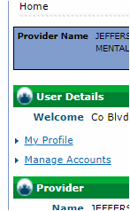

1. Click🡪 **Link Registered Delegate/Office Staff** This only gives me permission to complete a Provider Maintenance and the Revalidation on your account.

Type in the following information.

Last Name: **Dallarosa**

Delegate Code: **89657**

Click the boxes for**: Provider Maintenance**

**Revalidation**

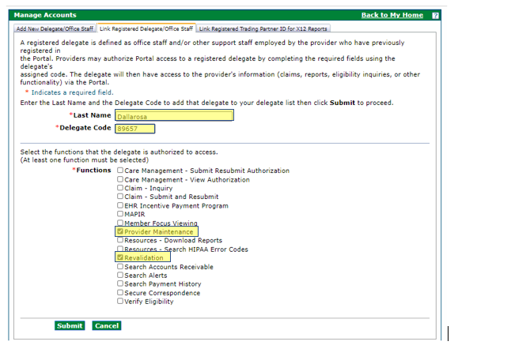

1. Click 🡪 **Submit**
2. Confirm Details

**The following details should be on the bottom of that page after confirmation.**

